Assignment: MySQL Countries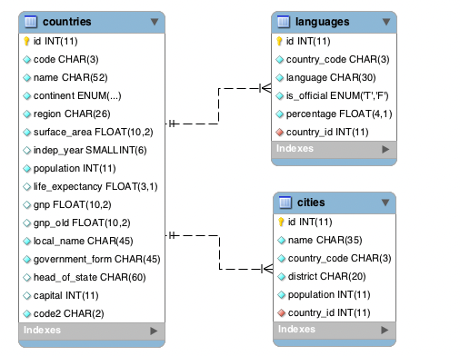

1. **What query would you run to get all the countries that speak Slovene? Your query should return the name of the country, language and language percentage. Your query should arrange the result by language percentage in descending order. (1)**

SELECT name, language, percentage FROM world.languages

JOIN countries ON country_code = languages.country_code WHERE language = "Slovene" ORDER BY percentage DESC;

1. **What query would you run to display the total number of cities for each country? Your query should return the name of the country and the total number of cities. Your query should arrange the result by the number of cities in descending order. (3)**

SELECT COUNT(cities.name), countries.name FROM world.cities

JOIN countries ON code = cities.country_code GROUP BY countries.name;

1. **What query would you run to get all the cities in Mexico with a population of greater than 500,000? Your query should arrange the result by population in descending order. (1)**

SELECT * FROM world.cities WHERE country_code ="MEX" AND population > 500000 ORDER BY population DESC;

1. **What query would you run to get all languages in each country with a percentage greater than 89%? Your query should arrange the result by percentage in descending order. (1)**

SELECT name, language, percentage FROM world.languages

JOIN countries ON country_code = languages.country_code WHERE percentage > 89 ORDER BY percentage DESC;

1. **What query would you run to get all the countries with Surface Area below 501 and Population greater than 100,000? (2)**

SELECT * FROM world.countries

WHERE surface_area < 501 AND population > 100000;

1. **What query would you run to get countries with only Constitutional Monarchy with a capital greater than 200 and a life expectancy greater than 75 years? (1)**

SELECT * FROM world.countries

WHERE government_form = "Constitutional Monarchy" AND capital > 200 AND life_expectancy > 75;

1. **What query would you run to get all the cities of Argentina inside the Buenos Aires district and have the population greater than 500, 000? The query should return the Country Name, City Name, District and Population. (2)**

SELECT countries.name, cities.name, district, cities.population FROM world.countries

JOIN cities ON country_id = countries.id

where code ="ARG" and district = "Buenos Aires" and cities.population >500000;

1. **What query would you run to summarize the number of countries in each region? The query should display the name of the region and the number of countries. Also, the query should arrange the result by the number of countries in descending order. (2)**

SELECT COUNT(name), region FROM world.countries GROUP BY region;